Feature Engineering
Teaching Notes
A from-scratch guide to building better model inputs out of the data you already have. Explains why raw columns alone are often not enough, with worked numeric examples for each technique, grounded in the loan-default case study's own verified results.

Contents

1. What Feature Engineering Actually Means
Every earlier case study fed a model a table of columns and let the algorithm find patterns in them. Feature engineering is the step before that: deliberately building new columns out of the ones you already have, so the patterns the model needs to find become easier, or in some cases, possible at all, to find. It requires no new data collection, only arithmetic and domain knowledge applied to data already sitting in the table.
This matters because most models, logistic regression especially, are linear: they can only combine input columns by weighting and adding them together. Some real patterns simply cannot be built that way, no matter how much data the model sees. Feature engineering is how you hand the model a pattern it is structurally unable to discover on its own.

2. Ratio Features: When What Matters Is A Divided By B
A linear model can weight two columns separately, adding some multiple of column A to some multiple of column B. What it cannot do is compute A ÷ B, dividing one column by another is a nonlinear operation, entirely outside what a linear combination can represent. If the real driver of an outcome is a ratio between two raw numbers, a linear model fed only the two raw numbers is structurally blind to it.
Debt-to-Income (DTI) = Loan_Amount ÷ Annual_Income
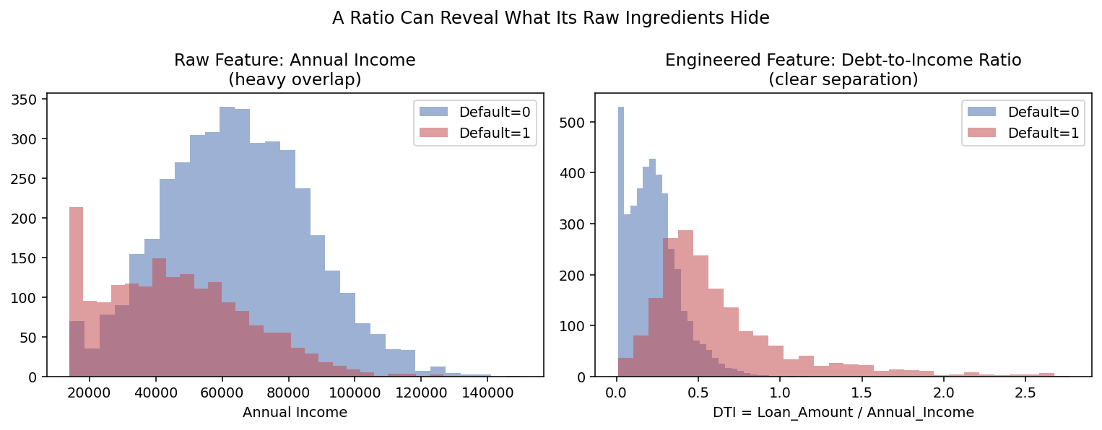
Figure 1. Left: raw Annual_Income, defaulters (red) and non-defaulters (blue) overlap heavily, income alone barely separates them. Right: the same applicants' DTI ratio, computed from those same two raw columns, shows a visibly clear split. The information was in the data all along, it just wasn't visible until the ratio was computed explicitly.
In the loan default case study, this single engineered column, built purely from two fields the bank already had, ranked as the single strongest predictor in the retrained model, ahead of every raw column including income and loan amount themselves.
- Look for a ratio feature whenever two raw columns are both individually weak predictors but plausibly relate to the same underlying concept (debt vs. income, clicks vs. impressions, price vs. square footage).
- A ratio is a strong candidate when the raw numerator and denominator individually show heavy overlap between classes, but domain knowledge says their relationship should matter.

3. Interaction Features: When A Rule Requires “And”
A linear model can also never represent a rule like “risk is high only when condition A AND condition B both hold.” Geometrically, a linear model can only ever separate its data with a single straight line (or, in higher dimensions, a flat plane). An “A and B” rule carves out a rectangular corner of the data, a shape no single straight line can trace:
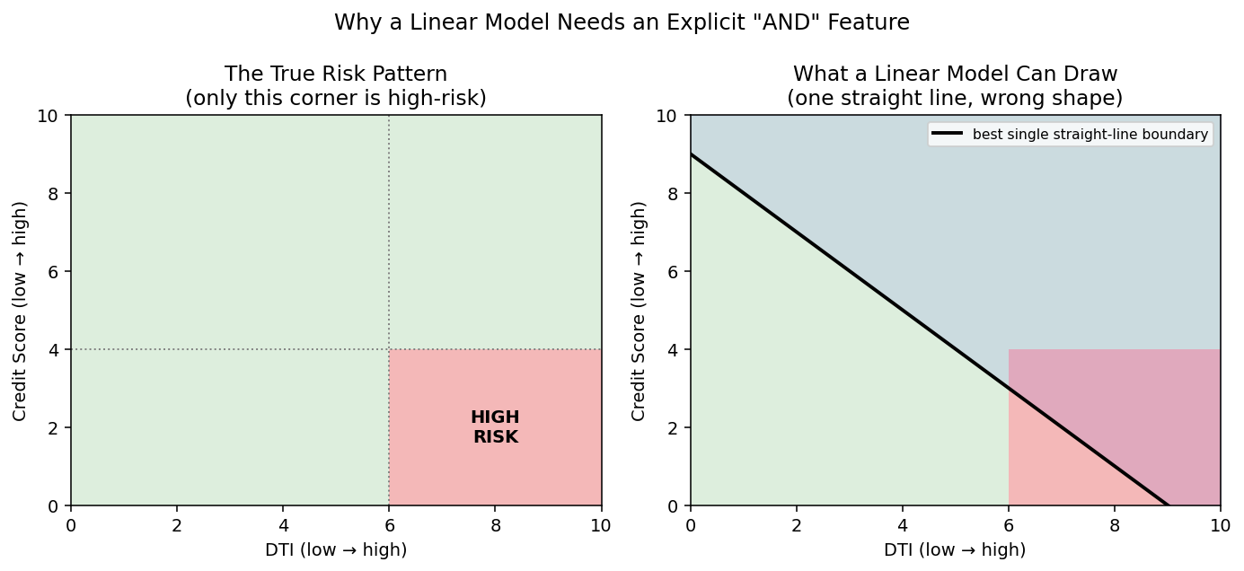
Figure 2. Left: the true pattern, only applicants with both high DTI and poor credit score are actually high-risk (bottom-right corner). Right: the best possible single straight line, a linear model's only tool, always gets some of the corner wrong on one side or the other, there is no straight line that matches the rectangle exactly.
The fix is to compute the “A and B” condition directly as its own 0/1 column, called an indicator or interaction feature, and hand that to the model as an input in its own right:
High_Risk_Combo = 1 if (DTI > 0.35) AND (Credit_Score < 600), else 0
In the case study, applicants flagged this way defaulted 98.7% of the time, versus 23.0% for everyone else, a dramatic split that a linear model can only exploit once the AND condition is computed for it in advance.

4. Binning: Trading Precision for Interpretability
Not every engineered feature is built to improve raw predictive accuracy, some exist to make a model's behavior easier for people to understand and act on. Binning converts a continuous number into a small number of labeled buckets, the exact numeric value is lost, but the result is something a non-technical stakeholder can immediately reason about.
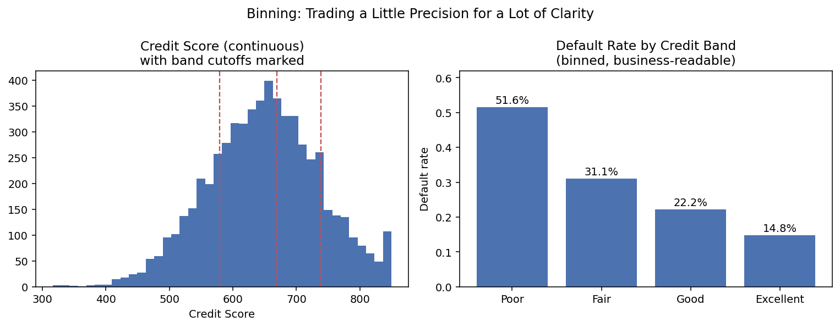
Figure 3. Left: the raw, continuous Credit_Score, with standard band cutoffs marked. Right: the same data collapsed into four familiar bands. The default rate drops steadily and monotonically from Poor (51.6%) to Excellent (14.8%), confirming the bands track genuine risk, even though no new information was added.
Binning is most useful when the audience for a result is not the model itself but a person: a loan officer explaining a decision, a regulator reviewing a policy, a dashboard for executives. The numeric column can, and usually should, stay in the model alongside the binned version, binning is a communication tool layered on top of the data, not typically a replacement for it.

5. Taming Skewed Features with a Log Transform
Many real-world quantities, income, prices, claim amounts, transaction values, are right-skewed: most values are modest, but a long tail of unusually large values stretches the distribution out. Left as-is, that long tail can dominate a model's calculations (especially for distance- or variance-based methods, the same concern behind standardizing before PCA). Taking the logarithm compresses large values proportionally more than small ones, pulling the tail in and leaving a far more symmetric, workable distribution:
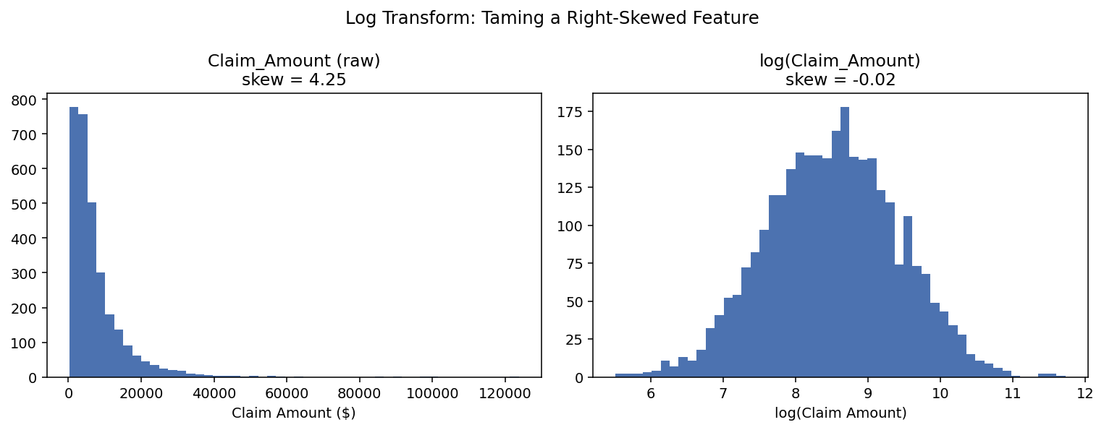
Figure 4. A right-skewed claim-amount variable (skew = 4.25, a small number of very large claims stretch the tail far to the right) becomes nearly symmetric after a log transform (skew = −0.02). The relative ordering of every value is preserved, only the scale changes.
- A common rule of thumb: consider a log transform when a feature's skew statistic is well above roughly 1, a quick, checkable diagnostic rather than a judgment call.
- Only works on strictly positive values; a small constant is sometimes added first (log(x + 1)) if zeros are present.
- This is the same idea used to normalize a skewed target variable in a regression problem, not just input features, log-transforming a right-skewed target before fitting a linear model is standard practice.

6. Encoding Categorical Variables
Models operate on numbers, so any text category (Home_Ownership, Purpose, and similar columns) must be converted to a numeric form before it can be used at all. The standard approach for linear models is one-hot encoding: create one new 0/1 column per category (dropping one category as the implicit baseline, to avoid redundancy).
Home_Ownership ("Own" / "Mortgage" / "Rent") becomes:
Home_Ownership_Mortgage (0/1), Home_Ownership_Rent (0/1)
("Own" is represented implicitly, by both columns being 0)
This is a necessary, mechanical form of feature engineering, without it, a model simply cannot accept the column at all, distinct from the ratio, interaction, and binning techniques above, which are about making already-numeric information easier to use rather than making non-numeric information usable in the first place.

7. Does It Actually Work? The Case Study's Verified Numbers
It's easy to claim feature engineering helps in the abstract. The loan-default case study tested it directly: the exact same logistic regression, the exact same train/test split, run once on the raw fields and once with the DTI and High_Risk_Combo features added.
Metric | Raw Features | Engineered Features
Recall | 0.811 | 0.780
Precision | 0.660 | 0.739
F1 | 0.728 | 0.759
AUC | 0.902 | 0.911

The honest result: not every metric improved. AUC and F1 both improved, but recall and precision traded places at the model's default classification threshold (recall dipped slightly, precision rose more).
AUC is the metric that matters most here: it measures how well the model ranks risky applicants above safe ones, independent of wherever a bank decides to set its approval cutoff. Because AUC improved, the bank can pick a new threshold that recovers the raw model's exact recall and still comes out ahead on precision, the engineered-feature model is a strict improvement once threshold is treated as a separate, adjustable business decision rather than fixed in advance. This kind of nuance, reporting what didn't improve alongside what did, is exactly what distinguishes a trustworthy result from a cherry-picked one.

8. Practical Guidance: What to Try, and When
Technique | Reach for it when… | Watch out for…
Ratio | Two raw columns individually overlap between classes, but domain knowledge says their relationship matters | Division by zero or near-zero denominators
Interaction / indicator | A rule genuinely needs “A and B”, not just A and B separately | Combinations rare enough to be noisy in a small dataset
Binning | The audience is a person, not the model, interpretability matters more than a small accuracy gain | Losing real signal if bins are too coarse; picking bin edges without checking they track the outcome
Log transform | A feature (or target) is strongly right-skewed (skew well above ~1) | Zeros or negative values (needs a shift first)
One-hot encoding | Any categorical column, mandatory before most models can use it at all | Very high-cardinality categories creating too many new columns

General workflow: start by plotting each raw feature split by outcome, as in Figure 1's left panel. Heavy overlap doesn't necessarily mean a feature is useless, it may mean the real signal is in a ratio, interaction, or transform of that feature rather than the raw value itself. Try the engineered version, then verify the effect with a real before/after comparison on held-out data (Section 7), the same discipline used throughout every case study in this series.

9. Summary Cheat Sheet
- Feature engineering builds new columns from data you already have, no new data collection required, to expose patterns a model couldn't otherwise represent.
- Linear models cannot compute a ratio (A÷B) or an AND condition on their own, if either genuinely drives the outcome, it must be engineered explicitly as its own column.
- Ratio features (like Debt-to-Income) turn two individually weak, overlapping raw columns into one column with real separating power.
- Interaction/indicator features (like High-Risk Combo) let a linear model exploit a rule that only applies when multiple conditions hold together.
- Binning trades some numeric precision for interpretability, useful for the humans consuming a model's output, not usually a substitute for keeping the numeric version too.
- A log transform tames a right-skewed feature or target, checkable directly via its skew statistic, without changing the relative order of the data.
- Categorical columns must be one-hot (or otherwise) encoded before most models can use them at all, this is necessary, not optional.
- Always verify feature engineering's effect with a genuine before/after comparison on held-out data, and report honestly on every metric, not just the ones that improved (Section 7).

